DTU LiPo Charger v1.0 User Guide

1. Introduction
The DTU LiPo Charger v1.0 is a compact, adjustable USB-powered charger for single-cell (1S) lithium-polymer (LiPo) batteries. It is based on the MCP73831 linear charging IC and allows the user to select between several preset charge currents or configure a custom value.
This charger is intended for use with 3.7 V nominal / 4.2 V full-charge LiPo cells.
!!Do not use with LiFePO₄ or multi-cell batteries.!!

2. Hardware Overview & Connection Guide
Board Features:
- Type-C-USB Input (5 V): Primary power input for charging.
- Alt. Power Input (PTH header): 2-pin INPUT/GND pads for alternative 5 V power.
- Battery Outputs:
• JST Connector: JST SM02B-PASSTB(LF)(SN) which is compatible with standard 2 mm pitch LiPo connectors $(Pin 1=BAT-, Pin 2 = BAT+).$
•2-Pin Header (PTH): For soldered battery wires when no JST plug is available.
!!Connect only one battery at a time.!!
- PROG DIP Switch (SW1–SW6): Selects the charge current.
- Status LED: Indicates charger operation (linked to the MCP73831 STAT pin).
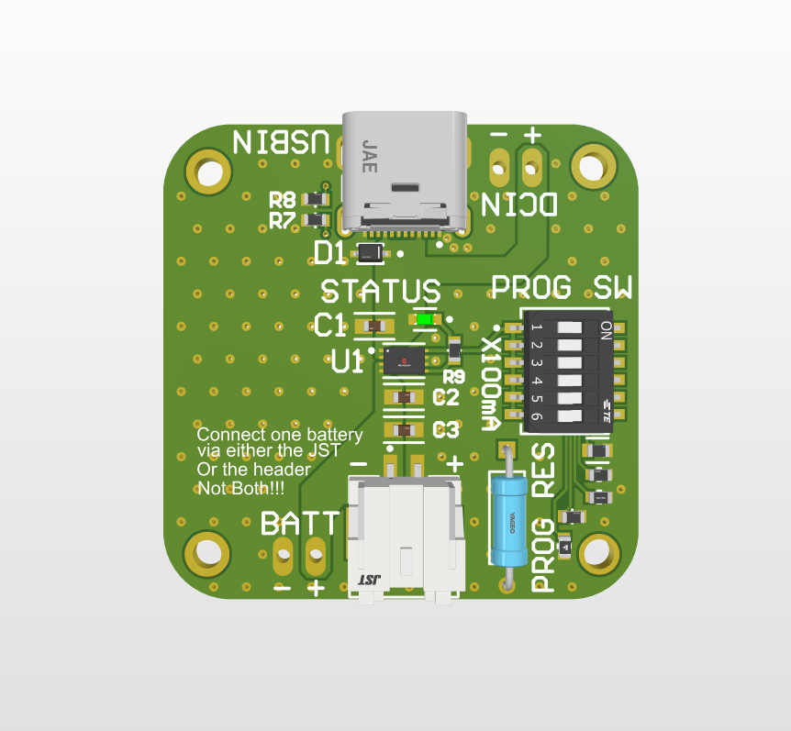

3. Configuration and Usage
Charge Rate Selection:
Switch | Charge Current
1 | 100 mA
2 | 200 mA
3 | 300 mA
4 | 400 mA
5 | 500 mA
6 | User-soldered resistor (PROG RES)
!!Only one switch should be ON at a time.!!
Custom Charge Current:
Switch 6 enables a solderable PROG RES pad for user-defined current control. The MCP73831 follows:

$$I_{REG} =\frac{ 1000V}{R_{PROG}}$$
Example: For 250 mA charging current, $R_{PROG} =\frac{ 1000V}{0.25A} = 4.0 kΩ$.
Use a 1% tolerance resistor for accuracy.

Charging Procedure:
1. Connect a single 3.7 V LiPo battery to either the JST or 2-pin header.
2. Select the desired charge rate using the DIP switch.
3. Plug in a Micro-USB cable (5 V power source).
4. Observe the status LED for charging indication.
5. When the LED turns off, charging is complete.
6. Unplug USB and disconnect the battery safely.

4. LED Status and Feedback
Condition | STAT Pin | LED State | Meaning
No Battery | High-Z | OFF | No battery detected.
Shutdown (no USB/VDD) | No Power | OFF | Charger unpowered.
Charging (USB + Battery) | Low ≈ 0 V | ON | Battery charging.
Charge Complete | High ≈ VDD | OFF | Charging complete.

5. Important Safety Warnings
!! Do not enable multiple DIP switches simultaneously, this causes excessive current and may damage the IC or battery.
!! Connect only one battery. Connecting to both JST and PTH outputs can cause unsafe current flow.
!! Battery type: Only for 3.7 V LiPo cells (4.2 V max). Not suitable for LiFePO₄.
!! High charge rate: Ensure the battery supports the selected current. 500 mA is suitable for ≥500 mAh 1C cells.
!! Always supervise charging. Stop if the battery swells, overheats, or emits odor.

6. Connector Reference
JST Battery Connector:
Model: JST SM02B-PASS-TB(LF)(SN)
Pitch: 2.0 mm
Orientation: Side-entry, surface-mount
Pinout:
• Pin 1 = BAT–
• Pin 2 = BAT+

